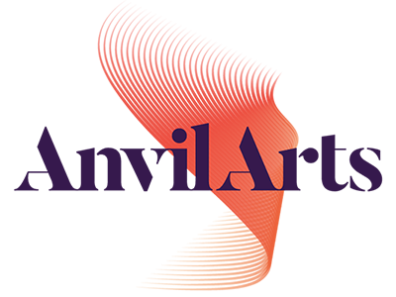
GIFT AID FORM
Using Gift Aid means that for every pound you give, we can claim extra from
the Inland Revenue, helping your donation go further
1 Name of Charity: The Anvil Trust (charity no. 1034961)
Please treat the gift as…….
☐ a Gift Aid Donation made today
☐ all gifts of money that I make today and in future as Gift Aid donations
☐ a Gift Aid Donation made from today onwards and in the past 4 years
You must pay an amount of income tax and/or capital gains tax in each tax year (6 April one year to 5 April the next) that is at least equal to the amount of tax that the charity will claim from HM Revenue & Customs on your Gift Aid donation(s).
2 Your Details
Name ……………………………………………………
Address ……………………………………………………
……………………………………………………
Post Code ……………………………………………………
Phone No …………………………………………………..

Signature ………………………………………………………..
Date …./…../…..

