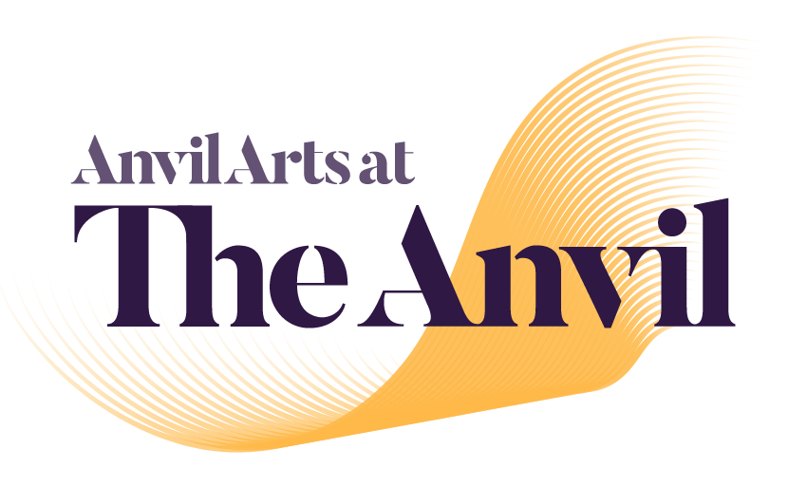

Visual Story

This Visual Story can be used to support and prepare people attending a performance at The Anvil.

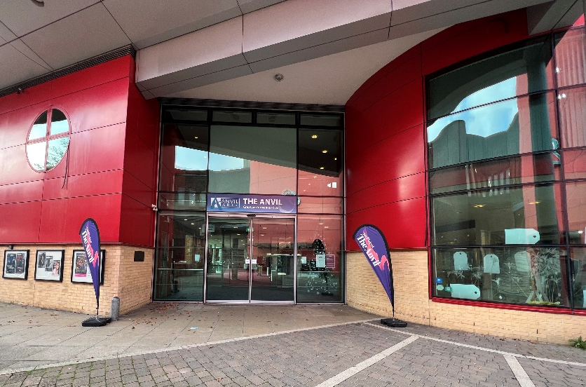
Welcome to The Anvil.

The glass door will open
automatically as you walk towards it.

There could be lots of people when you come in; it can be noisy. You can put your hands over your ears.

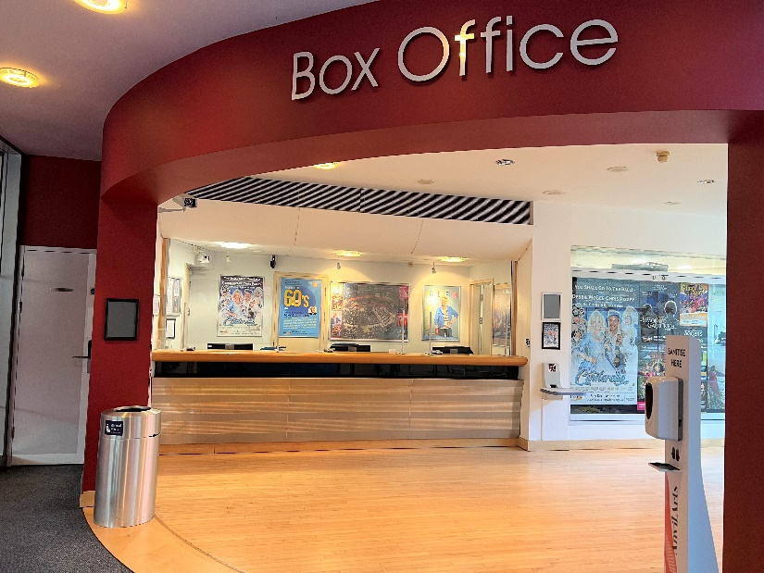
If you do not have tickets, you can buy or collect them from the box office.

You may have to stand in a line with other people and wait your turn.

You will see lots of posters on the walls and leaflets about other shows.

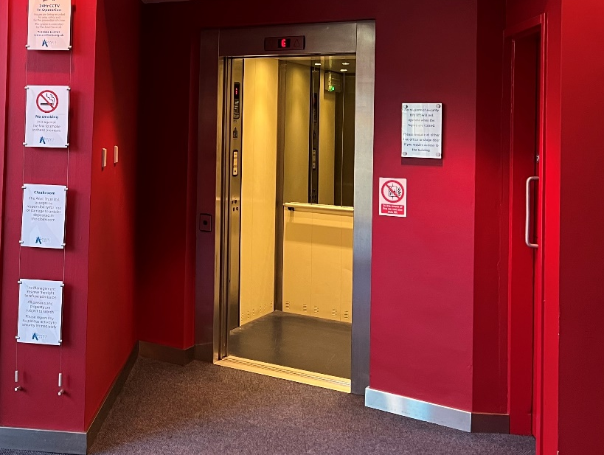
There is a lift which will take you to the Upper Foyer.

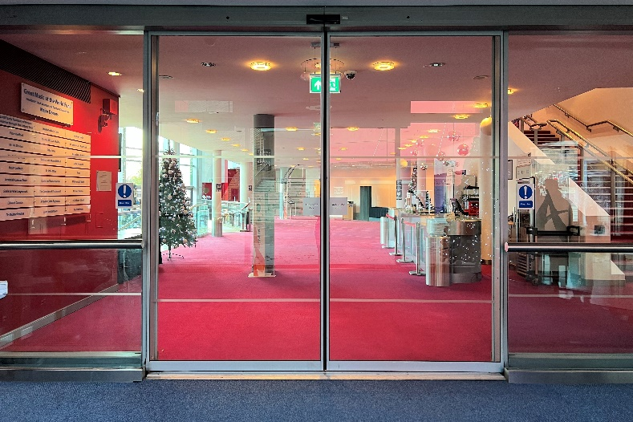
Our staff wear a black uniform and a lanyard or ID badge with their photo, and they can help you if you have a question.

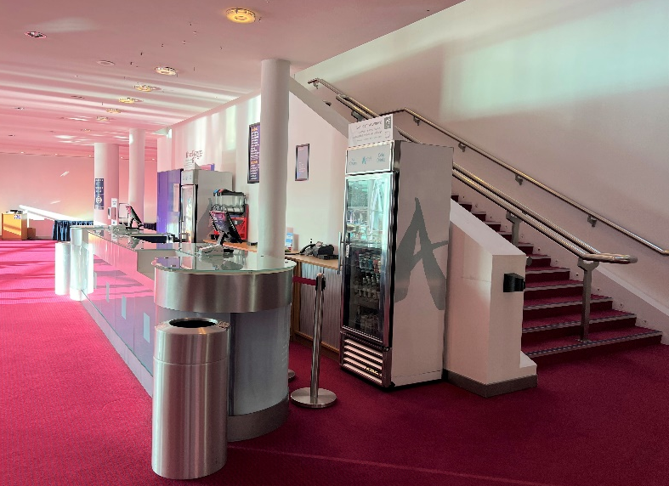
Walk in to the Lower Foyer. There could be lots of people when you come in, and it can be noisy. Again, you can put your hands over your ears.

Use this level for Door A and Door B into the auditorium.

Your tickets will show the door letter which is nearest to your seat.

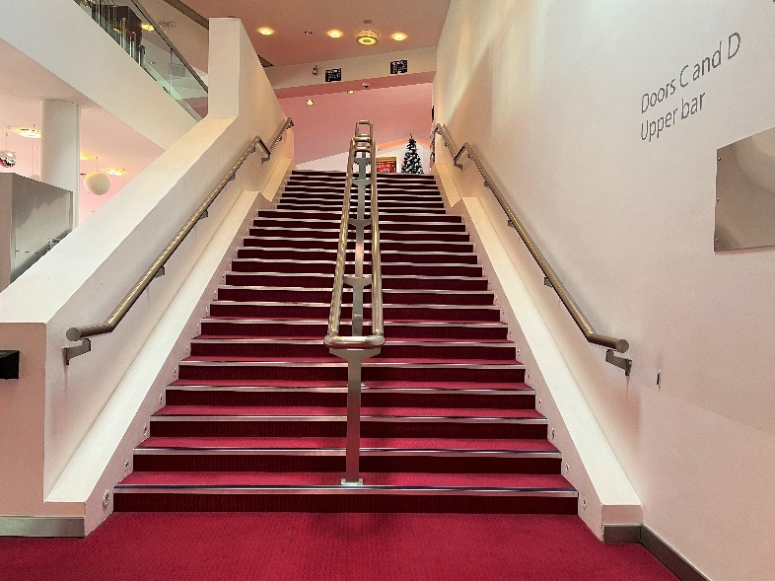
You can use the stairs to go to the Upper Foyer, where you will find Door C and Door D.
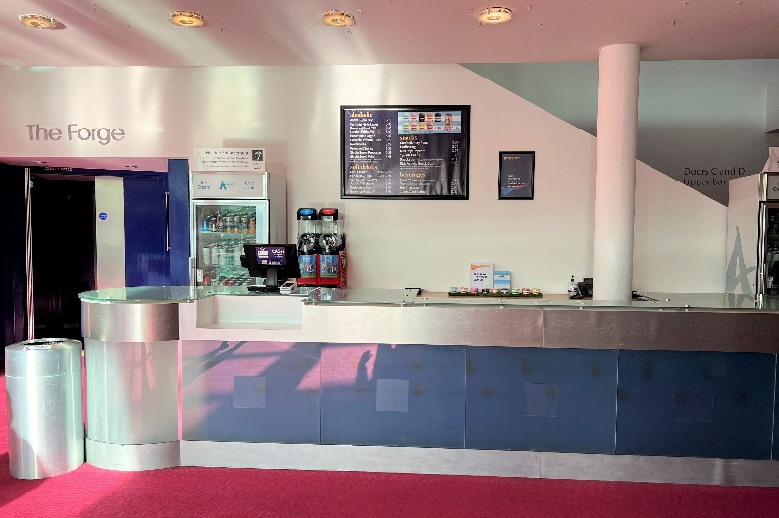
You can buy drinks and snacks from the serving area.

You may have to stand in a line with other people and wait your turn.

Staff will be serving behind the counter.

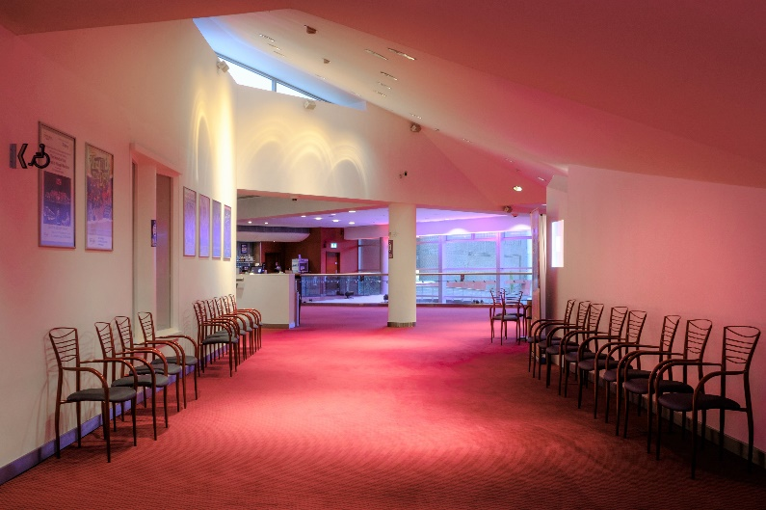
Use the Upper Foyer level for Door C and Door D into the auditorium.

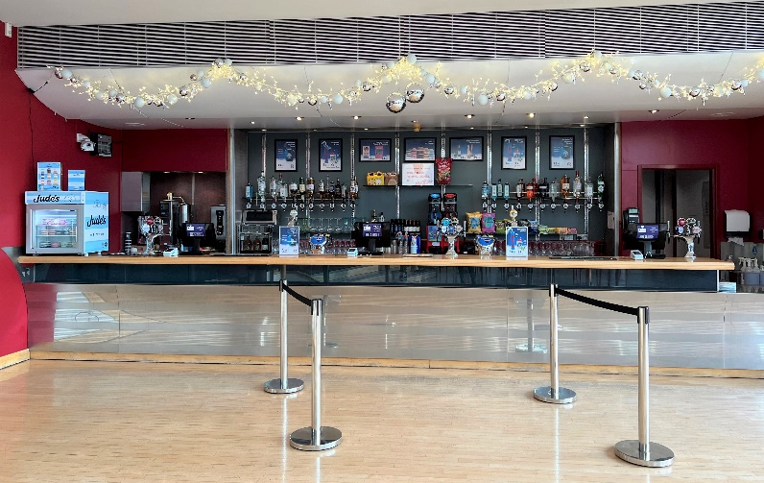
You can also buy drinks from the bar.

Staff in their black uniform will be serving behind this area.

There are male, female, and accessible toilets in both the Lower Foyer and Upper Foyer.

There are two sets of doors to walk through when you go to the toilet – other people may be coming in and out of these doors.

Additional pictorial access information is available at accessable.co.uk/venues/anvil.

The nearest Changing Places toilet facilities are located at:

- The Malls Shopping Centre, located next to Primark and The Malls car park lifts. These are available at a cost of 20p. A radar key is required. Find out more at accessable.co.uk/venues/the-malls-shopping-centre.

- The Discovery Centre. Find out more at accessable.co.uk/venues/basingstoke-discovery-centre-and-library.

You may hear a noise and an announcement in the Foyer letting you know when you can go into the auditorium – this may be loud so that everyone can hear.

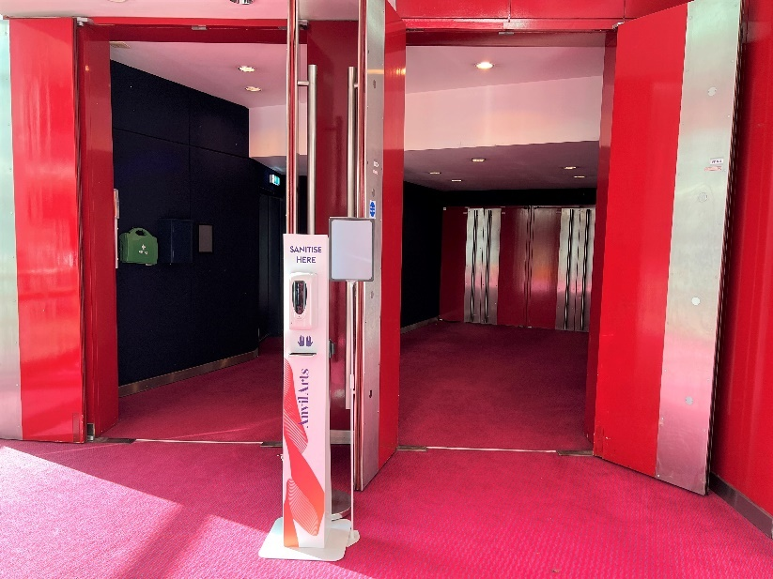
The auditorium doors will normally open 30 minutes before the start of the show. You may hear music coming from inside the auditorium.

Have your paper ticket or e-ticket on a mobile device ready to show a member of staff.

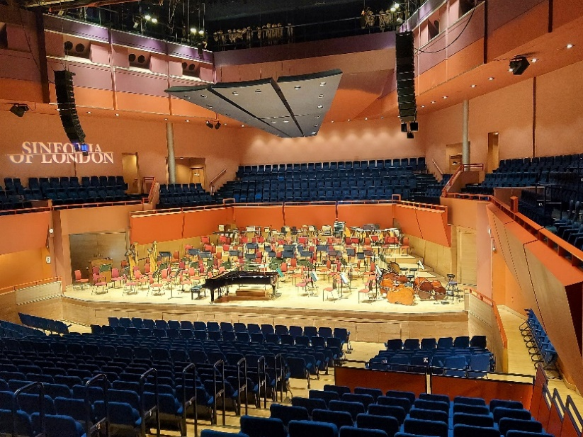
You will go inside the auditorium. There are lots of seats, which are all blue. It might be quite busy.

Music may be playing, and you may know the music. You can sing, dance and clap along if you want to.

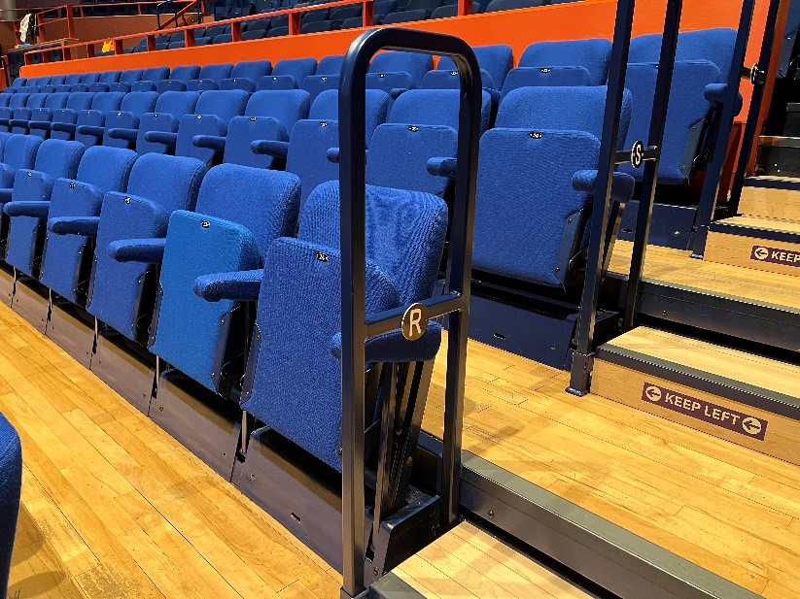
There is a letter and a number on your paper ticket or e-ticket on mobile device which tells you where you are sitting. You can ask a member of staff to help you find your seat.

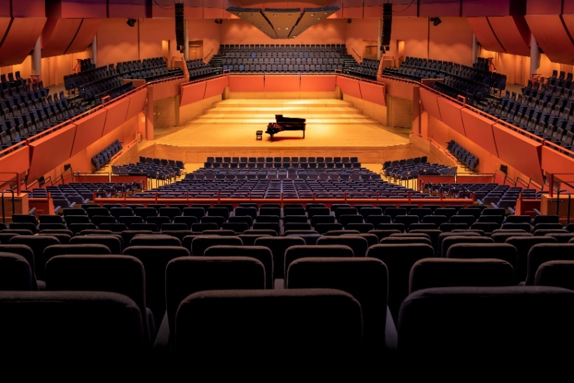
The lights go darker at the start of the show.

During the show, it is good to be quiet so that you can hear everything.
If you would like to leave then you can go back into the foyer with a parent, carer, or adult accompanying you.

During the show there may be singing, shouting, and dancing. Sometimes it might be loud. You can cover your ears if you want to. You may hear songs that you know, and you might feel happy or sad. It is okay to laugh or cry if you feel like it.

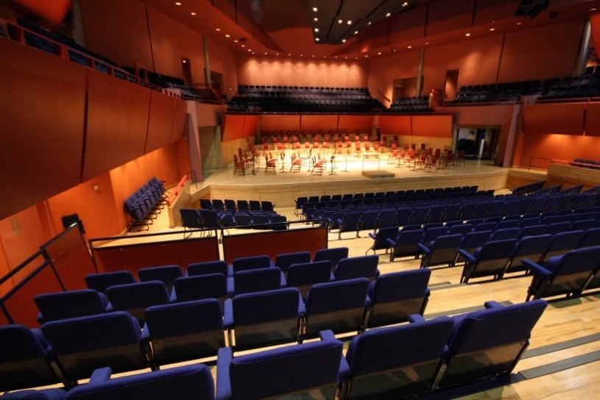
There may be a brief break during the show. This is when the show will stop, and you can go to the toilet or have a drink if you want to.

People might start clapping – you can join in if you like. It tells everyone that you are enjoying the show.

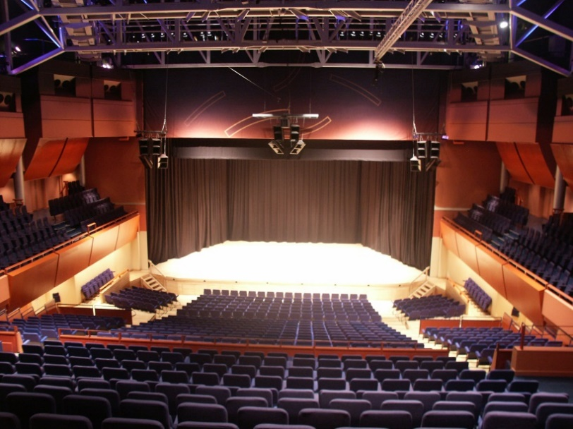
The show will then start again, and the lights will go dark again.

Some time later, at the end of the show, the performers on stage may bow.

You can clap again to show how much you enjoyed the show. Other people will be clapping – it may be loud. The lights will get brighter again.
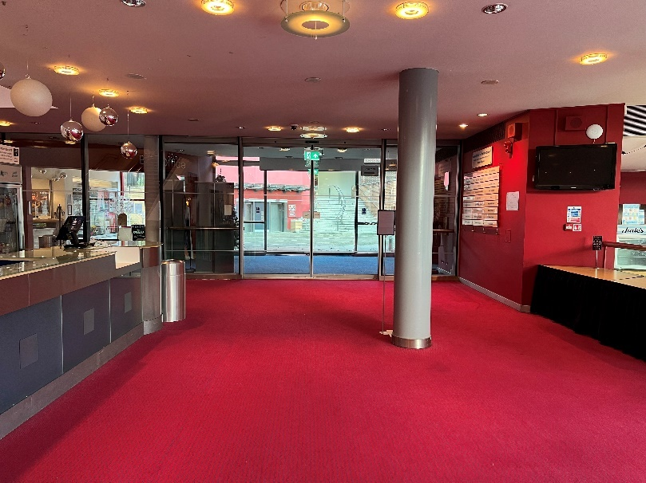
Everyone leaves at the end of the show.

You can make a visit to the toilet if you want to.

The foyer will be busy and there may be a lot of noise. You can put your hands over your ears.

Thank you for visiting The Anvil

We hope you had fun at The Anvil! You can tell us about your visit if you would like to.

When you get home, you could write us a letter, draw a picture, or email us on comments@anvilarts.org.uk.

Thank you for coming, and we hope to see you again soon.

