The

Visual Story

This Visual Story can be used to support and prepare people attending a performance at The Haymarket.

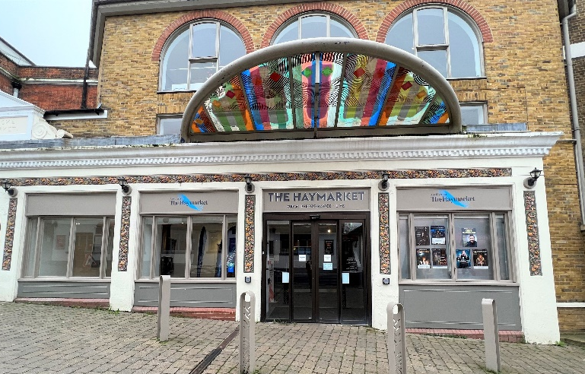
Welcome to The Haymarket.

The glass door will open automatically as you walk towards it.

There could be lots of people when you
come in. It can be noisy. You can put your hands over your ears.

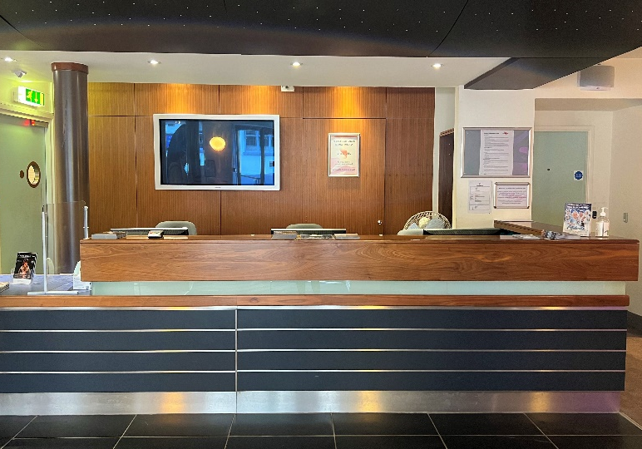
Through the doors is the box office.
You can buy or collect your tickets from here. You may have to stand in line with other people and wait your turn.

You will see lots of leaflets about other shows and some posters.

A member of staff will check and scan your tickets (or e-tickets on a mobile device) and tell you where to go next.

Have your paper ticket or e-ticket on a mobile device ready to show a member of staff.

Your tickets will show the door letter which is nearest your seat.

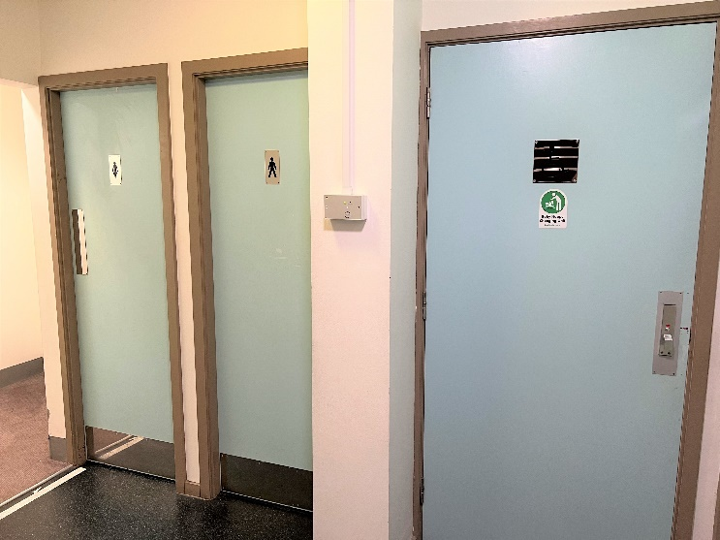
To the left of the box office there are male, female, and accessible toilets.

There are two sets of doors to walk through when you go to the toilet. Other people may be coming in and out of these doors.

Additional pictorial access information is available at accessable.co.uk/venues/haymarket.

The nearest Changing Places toilet facilities are located at:

- The Malls Shopping Centre, located next to Primark and The Malls car park lifts. These are available at a cost of 20p. A radar key is required. Find out more at accessable.co.uk/venues/the-malls-shopping-centre.

- The Discovery Centre. Find out more at accessable.co.uk/venues/basingstoke-discovery-centre-and-library.

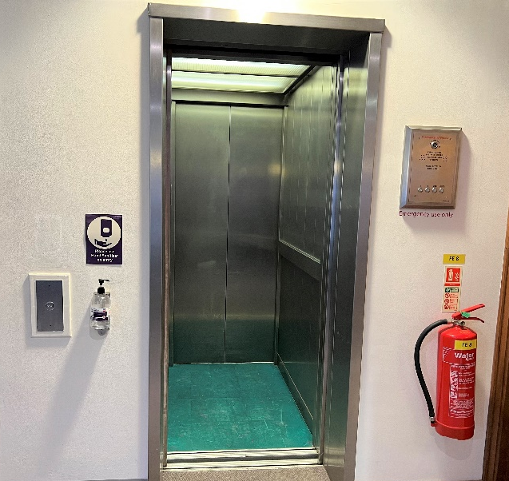

A lift is located to the right of the box office. It can take you to both the First and Second Floor.

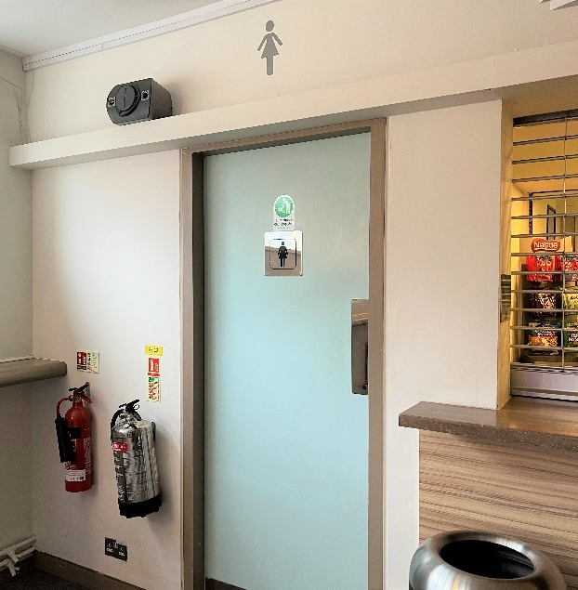
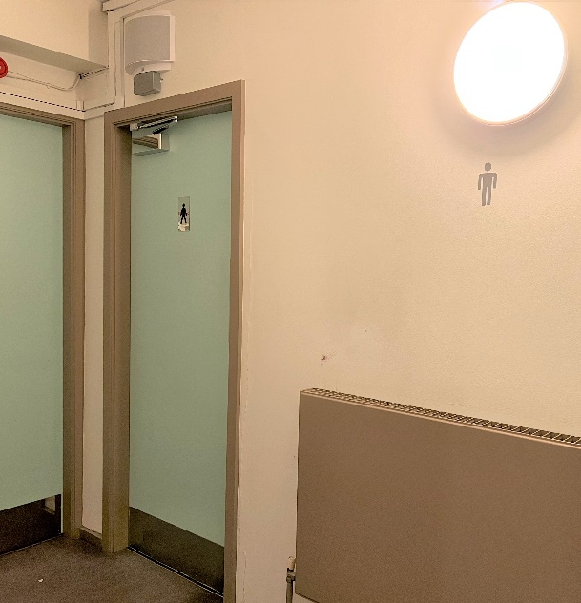
There are male and female toilets on this floor.

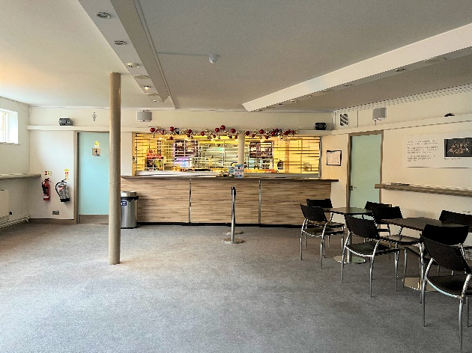
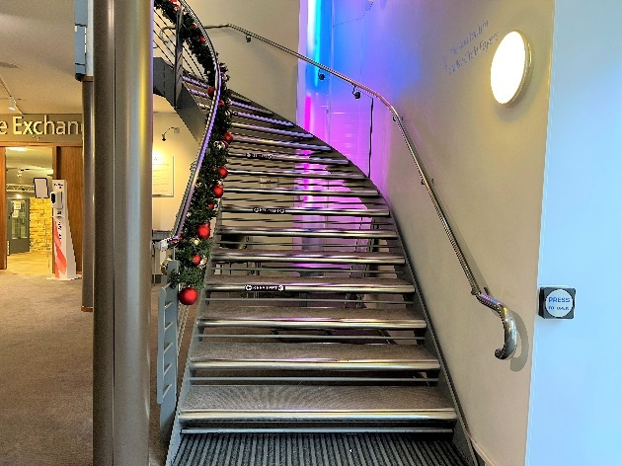
You can also use the stairs to go to the First Floor Foyer.

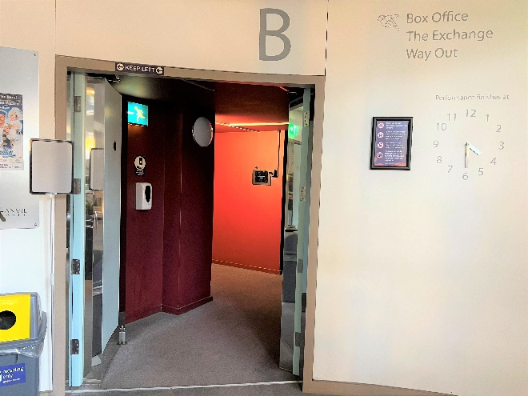
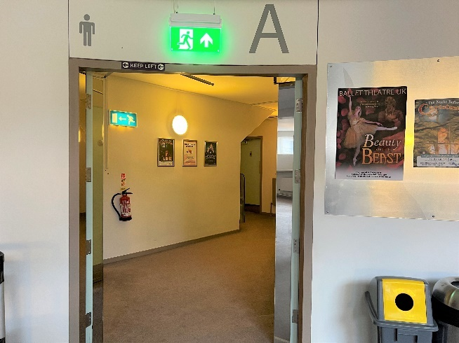
Use this First Floor level for Door A and Door B into the auditorium.

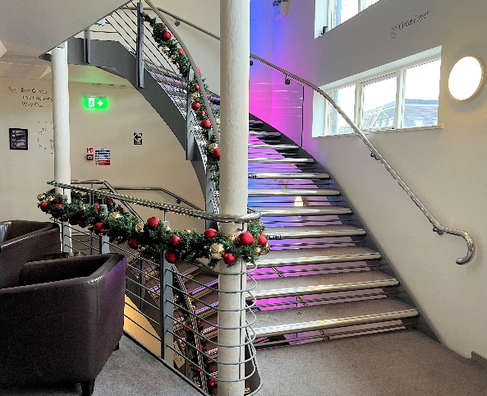
There is another set of stairs which will take you to the Second Floor Foyer.

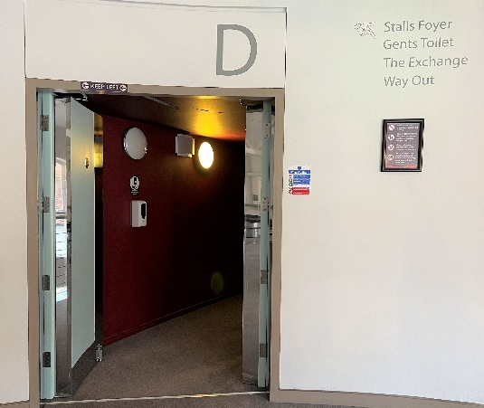
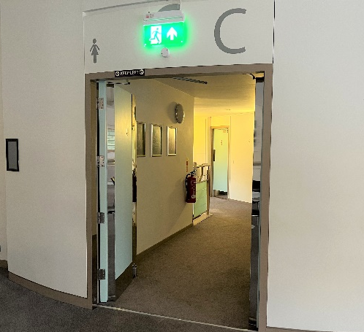

Use this Second Floor level for Door C and Door D into the auditorium.

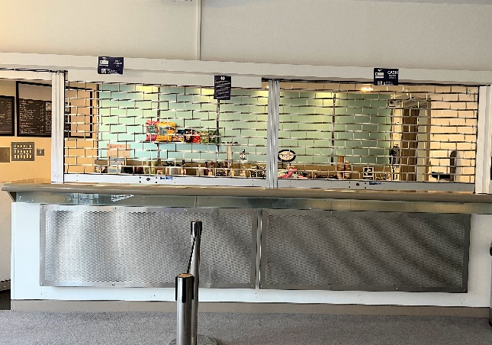
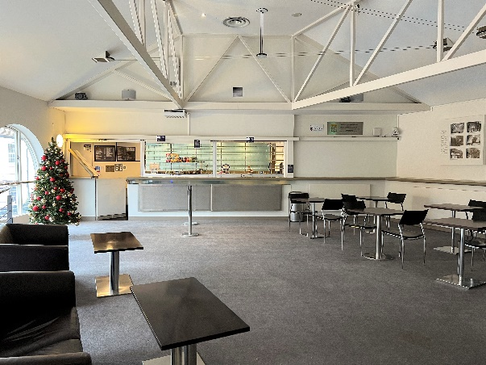
You can buy drinks, snacks, and ice cream from the bar. Staff will be serving behind this area.

You may have to stand in line with other people and wait your turn.

You may hear a noise and an announcement in the Foyer letting you know when you can go into the auditorium – this may be loud so that everyone can hear.
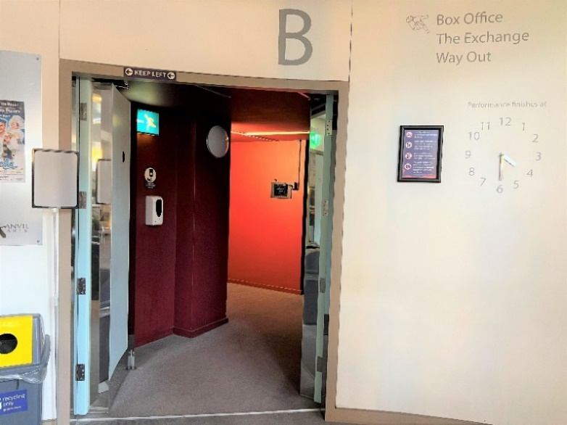
The auditorium doors will normally open 30 minutes before the start of the show. You may hear music coming from inside the auditorium.

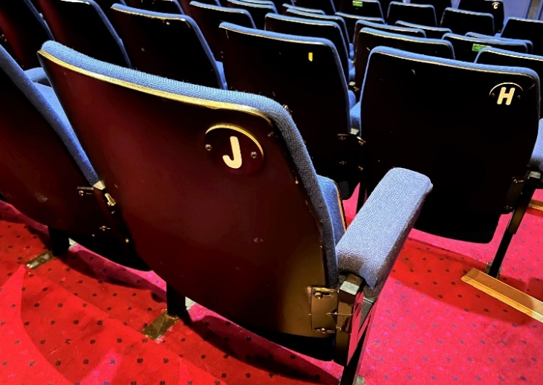
You will go inside the auditorium. It is very big and there are lots of seats, which are all blue.

There is a letter and a number on your paper ticket or e-ticket on mobile device which tells you where you are sitting. You can ask a member of staff to help you find your seat.

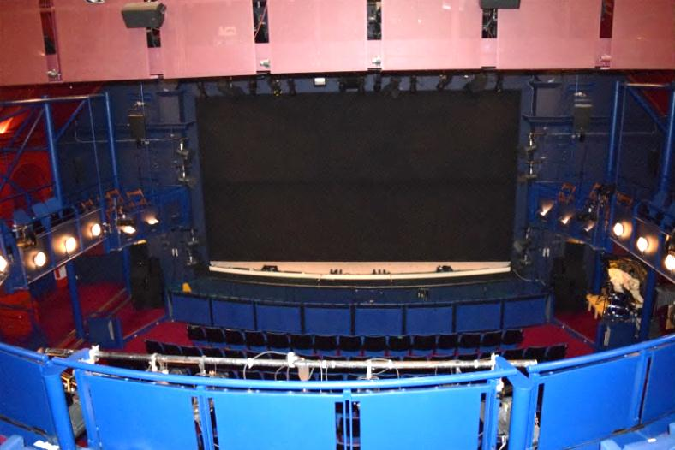
The lights go darker at the start of the show.

During the show, it is good to be quiet so that you can hear everything.

There may be singing and dancing. You may feel happy or sad while you are watching the show. It is ok to laugh or cry if you feel like it.

There may be a brief break during the show. This is when the show will stop, and you can go to the toilet or have a drink if you want to.

If you would like to have a break, you can go back into the foyer with a parent, carer, or adult accompanying you.

People might start clapping – you can join in if you like. It tells everyone that you are enjoying the show.

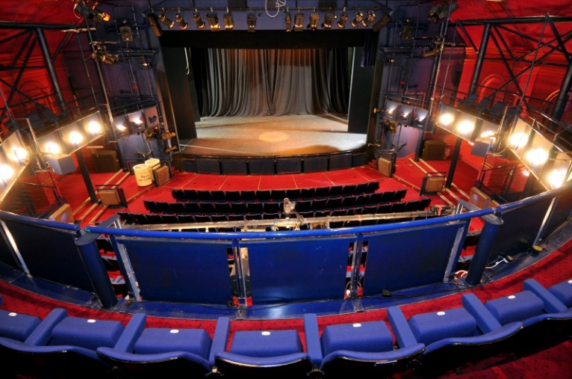
At the end of the show, the performers on stage may bow. You can clap again to show how much you enjoyed the show. Other people will be clapping – it may be loud.

The lights will get brighter again.
This is the end of the show.

When you are ready, you will exit from the auditorium.

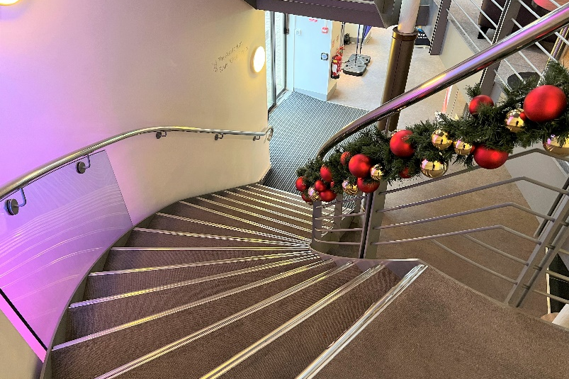
The foyer will be busy and there may be a lot of noise. You can put your hands over your ears if you like.

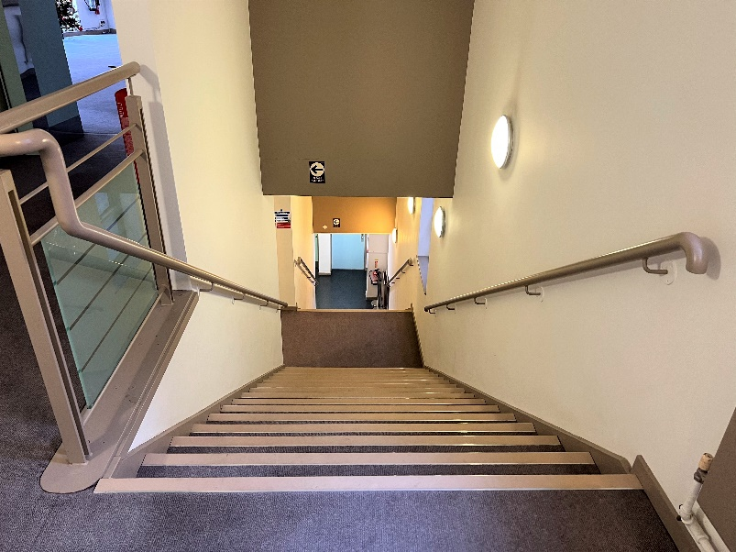
There is another staircase you can use on your way out if you’d prefer. This may be less crowded.

Everyone then leaves The Haymarket at the end of the show. You can go to the toilet if you want to before you go home.

Thank you for visiting The Haymarket

We hope you have fun at The Haymarket! You can tell us about it if you would like to.

When you get home, you could write us a letter, draw a picture, or email us at comments@anvilarts.org.uk.

Thank you for coming, and we hope to see you again soon.

