GROUPS’
INFORMATION PACK

CONTENTS

WELCOME 3
CONTACTING US 3
HOW TO FIND US 4
BOOKING YOUR GROUP TICKETS 6
INFORMATION FOR YOUR VISIT 7

WELCOME
This information pack has been prepared to help you plan a group visit to The Anvil or The Haymarket. Should you have any questions which are not covered, please contact the Group Booking line using the details below.

CONTACTING US

GROUP BOOKING
Group Booking Line: 01256 366935

Email: group.booking@anvilarts.org.uk

Post: Anvil Arts Group Booking
Churchill Way
Basingstoke
Hampshire
RG21 7QR

OTHER CONTACTS

Box Office
Phone: 01256 844244

Email: box.office@anvilarts.org.uk

Fax: 01256 366900

Textphone
Use a Typetalk operator by prefixing the call with 18001

Online
anvilarts.org.uk/your-visit/groups

BOX OFFICE OPENING TIMES
Anvil box office:
Monday – Friday, 10am – 2pm

Performance nights
Open one hour before the performance

Haymarket box office:
Open one hour before every performance

HOW TO FIND US
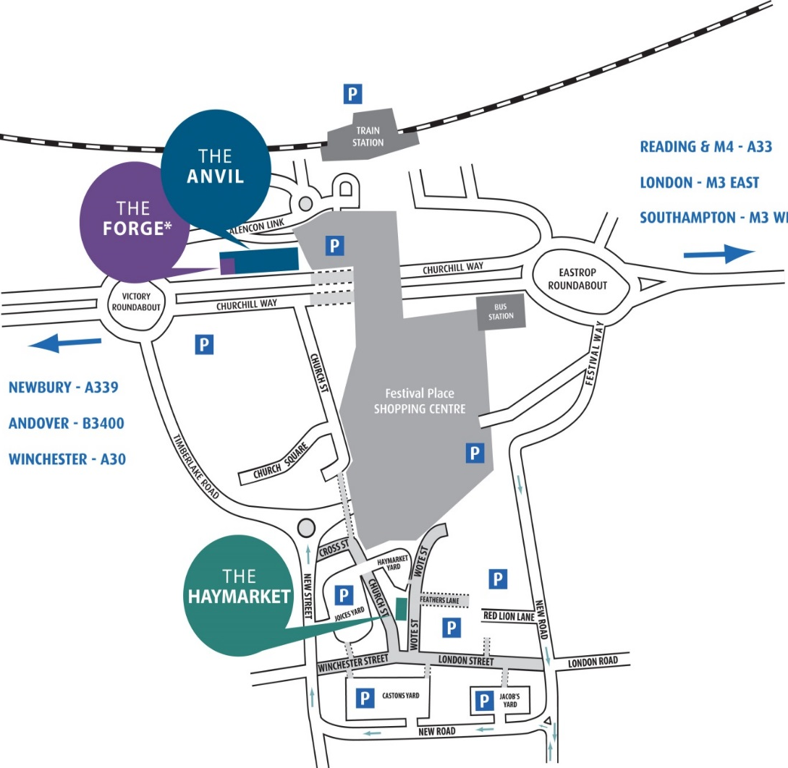

THE ANVIL & THE FORGE
By coach
Coach drop off points are outside The Anvil on Churchill Way. Coach parking is available on the opposite side of the Churchill Way dual carriageway.

By train
The Anvil is just across the road from Basingstoke Train Station. From the station, walk down the concourse steps and over the zebra crossing. Turn right, past the bus stops and along the outside of the building on your left. The Anvil is the red and silver building down the steps ahead of you. Basingstoke is on the London Waterloo line; 45-60 mins from Waterloo, 30-35 mins from Southampton Central.

By car
Basingstoke is at Junction 6 of the M3, and on the A33 south of Reading. Follow signs for Town Centre and brown signs to The Anvil. For sat nav or route planning, the postcode for The Anvil and The Forge is RG21 7QR.

THE HAYMARKET
By coach
The coach drop-off point is in Red Lion Lane, a short walk away from Wote Street.

By train
Basingstoke Train Station is a 10-to-15-minute walk away through The Malls and Festival Place shopping centre. Once in Festival Place take the south exit.

By car
From the ring road or M3 Junction 6, follow signs to Basingstoke town centre and then brown signs for The Haymarket. For sat nav or route planning, the postcode for The Haymarket is RG21 7NW.

BOOKING YOUR GROUP TICKETS

BOOKING
- To make a booking, please email group.booking@anvilarts.org.uk or call the Group Booking Line on 01256 366935. Group bookings cannot be made online.
- Groups are not required to pay straight away, and no deposit is needed. Reservations will be held until one month before the performance date, or until the performance sells out, whichever is sooner. If the booking is made within a month of the performance date, then special terms may apply.
- You can adjust the number of tickets until the payment date (subject to availability). If any changes cause the total number to fall below the qualifying size for a group booking, the full price will apply.
- Once payment is made, any further tickets will be treated as a separate transaction and are not eligible for the group discount.
DISCOUNTS
Group discounts vary depending on the performance. They are available where stated. Ticket prices, discounts and availability are set by the visiting companies.
ACCESS
Please help us to give you a better service by letting us know at the time of booking if any of your group has specific access needs or requires a wheelchair position. We have a limited number of wheelchair positions available for which you need to have specific tickets. In order to book these seats please join our Access List. Visit anvilarts.org.uk/access for more information.
PAYMENT
We accept Mastercard and Visa as well as a company/group cheque. BACS payments can be made directly to Anvil Trust Ltd. We do not accept personal or post-dated cheques or payment after the performance, and request that cheque payments are made with a single cheque.

TICKETS
If you are arriving together, we will issue a group booking voucher to help seat you quickly and efficiently on the day. Should you prefer individual tickets, we recommend that you keep a written record of which tickets you allocate to each member of your group.
If you require your individual tickets to be sent to you, postage is £1.50.

INFORMATION FOR YOUR VISIT

BEFORE YOUR VISIT
- A group booking voucher will be sent to you showing the location of your seats. This will be issued instead of tickets unless otherwise requested. Please bring this with you so our Front of House staff can seat you quickly and efficiently.
- Pre-order your ice creams and drinks before your visit. A pre-order discount is available on ice creams for groups of ten or more. Order online at anvilarts.org.uk/preorder

ARRIVING
- Please arrive at least 30 minutes prior to the start of the performance.
- There are cloakrooms at The Anvil and The Haymarket where you can leave coats and bags if required.
- The doors to the auditorium usually open about 15 minutes before the performance starts.
- Latecomers cannot be guaranteed access until a convenient break in the performance and may not be seated in their original seat.

DURING THE PERFORMANCE

Photography and recording including the use of mobile phones are strictly prohibited in the auditoriums.

Please remind your group that mobile phones and other electronic devices need to be switched off during the performance.

If you have any questions or problems during your visit, please talk to a member of Front of House staff. You will be able to easily identify the team by their black uniform and badges.

The interval is usually about 15-20 minutes long.

AFTER THE PERFORMANCE

Please remember to ensure no personal belongings have been left behind and have a safe journey home!

FOOD & DRINK

The bars at our venues are open one hour before the performance starts.

Bar snacks, ice creams, confectionary and hot drinks are available in the foyer. A pre-order discount on ice creams is available for groups of 10 or more. Order online at anvilarts.org.uk/preorder, selecting the correct venue, and using the unique barcode on your ticket. Alternatively, you will be sent a text message one week before the performance with a copy of your tickets and a link to a pre-order menu.
- Pre-order your ice creams and drinks before your visit: anvilarts.org.uk/preorder

Restaurants are mainly located in Festival Place, Basingstoke’s central shopping centre, which is very close to both our venues. We offer exclusive discounts for Anvil Arts customers at select restaurants nearby. Please visit anvilarts.org.uk/placestoeat for more information.

FIRST AID

First Aiders are on duty at all performances. Please speak to a member of Front of House staff should you require any assistance.

WE LOOK FORWARD TO SEEING YOU SOON

Staff at Anvil Arts are keen to ensure that you and your group have the best possible experience at any of our venues, so do not hesitate to ask for assistance during any part of the booking process or your visit.

We hope you enjoy the show!

